Low Protein Burrito Bowl

Makes: 1 serving
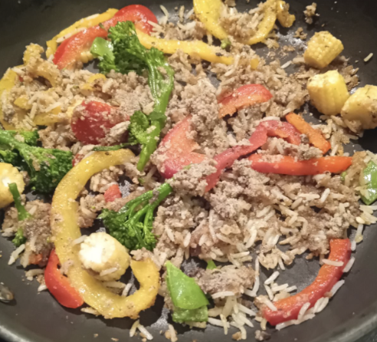

Exchanges:
1 (without baby corn)
2 (with baby corn)

Ingredients

- Promin Burger Mix Original/Chilli*
(1ex. For PKU, 0.5 ex. HCU and MSUD)
- Low Protein Rice 100g cooked
- 1/2 a pepper
- 1/2 onion
- 5 florets of broccoli
- 5 baby corn* (1 ex)
- Mange touts 50g
- 1 tsp garlic powder
- 1 tsp chilli powder/chilli flakes
- 1 tsp paprika
- 1 tsp onion powder
*Please note up to 8 florets of broccoli can be eaten freely. An extra portion of broccoli should be counted as one exchange.
- 1 tbsp of Tomato Puree
- 1 tsp olive oil
- Violife cheese (optional)

Method

- Place a saucepan on a medium boil and add the baby corn, broccoli and mangetout to the water. Cook for 10 mins.
- Heat a wok/pan to medium heat and add in 1 tsp of oil.
- Add peppers and onion to the wok and cook until soft.
- When your vegetables are boiled, transfer them into the wok and begin boiling the low protein rice according to its package.
- While the rice is cooking, make up the burger mix according to the packet and add to the wok with the vegetables and mix.
- Stir in all the seasoning to the wok along with the tomato puree.
- When the rice is cooked, add to the wok and mix together before serving.
- Top with some Violife cheese if you wish.

Thanks Lorraine- a parent, for the tasty recipe!

