Tangy Tabbouleh
Ingredients:
100g Promin low protein cous cous
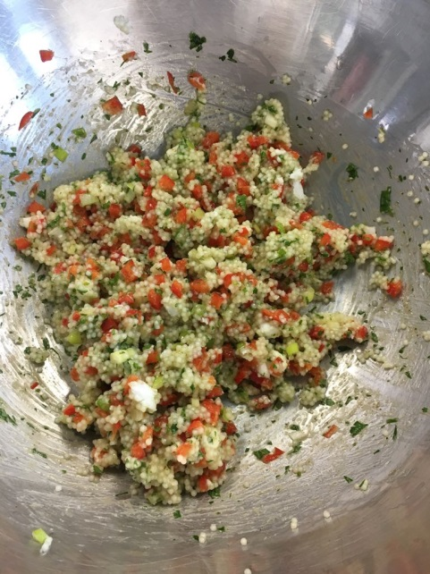
200ml water
½ stock baby stock cube
Red pepper
2 spring onions
1 teaspoon cumin
30g Vegan greek cheese ( Violife)
Lemon juice
Fresh coriander
Fresh mint

Equipment: Bowl, Measuring Jug, Pot, Wooden Spoon, Chopping Knife, Chopping board, Teaspoon
Prep time: 10mins Cooking time: 2 mins
Serving size: 4-6 adult portions
Method:
- Weigh out 100g of promin couscous and add to pot.
- Add 200ml of boiling water to the pot and ½ a baby stock cube.
- Stir continuously until water is absorbed – approximately 5 mins.
- Transfer couscous to a bowl to cool
- Meanwhile, finely chop the pepper, spring onion, vegan cheese and herbs and add to the cooled couscous
- Add 1 teaspoon of cumin and a squeeze of lemon juice
Switches
Add 1/3 of Avocado to the serving to include 1 exchange

