PKU Word Search

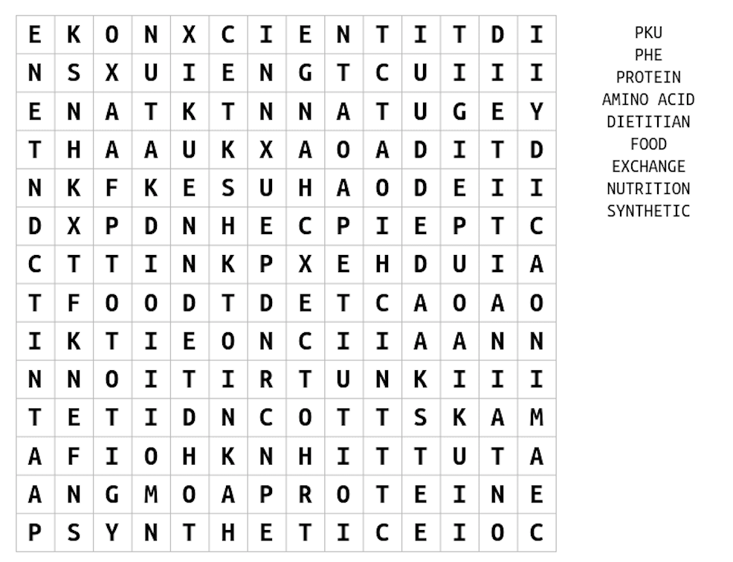
How many words can you find that relate to PKU and a low protein diet?

