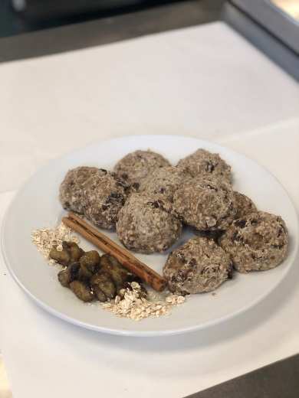
Oaty Banana Bites
Ingredients
3-4 ripe bananas
75g sultanas/ raisins
100g ground oats
180g low protein self-raising flour
½ tsp. cinnamon

Equipment
Large mixing bowl, wooden spoon, weighing scales, potato masher/fork, parchment paper, baking tray
Preparation and cooking time
Preparation time: 15 minutes
Cooking time: 15- 20mins
Serving size
Recipe makes 10 bites (1 bite = 1 portion= 1 exchange)
Nutritional information
Calories: 127kcals per bite
Allergens: sulphites (check sultana pack), gluten (oats)
No of exchanges: 1 exchange per 1 bite
Method
Pre heat the oven to 160°C.
In a large mixing bowl, mash the bananas using a potato masher or fork until there are no lumps and the mixture is as smooth as possible.
Stir in the flour, ground oats, raisins and cinnamon until well combined. If your mixture is runny and not very thick, add more low protein flour.
Mould the mixture into 10 balls and place onto a lined baking tray.
Bake for 15-20 minutes or until bites are firm to touch.

Switches
To adapt the recipe to contain the following exchanges per portion | Add or replace
2 | Add an additional 100g of oats and reduce low protein flour to 80g (New recipe: 200g oats + 80g low protein flour)
The portion size of the recipe can easily be adjusted according to your baby’s appetite and protein requirements. Remember the exchanges are coming from the oats in this recipe.
10g Oats = 1 Exchange

Chef’s tips
These bites are a great on the go snack idea which are delicious when served with fresh fruit.
Why not substitute the raisins with cranberries or dried apricots.
The cinnamon can be replaced with mixed spice for an extra punch of flavour.
Freezing
Freeze a batch of oaty banana bites and defrost as required.

