**Low Protein Cheese**

The following cheeses are free from exchanges:

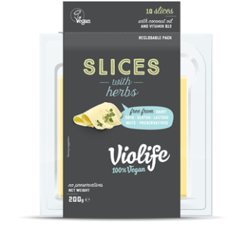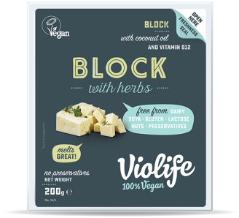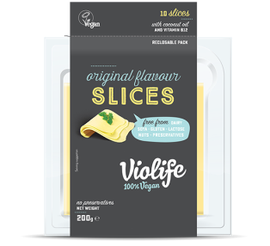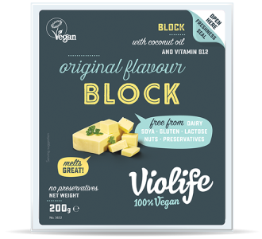

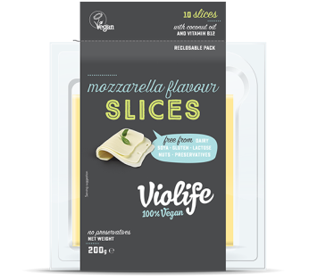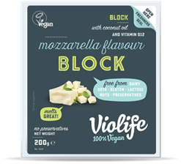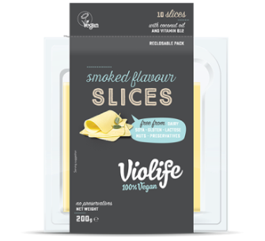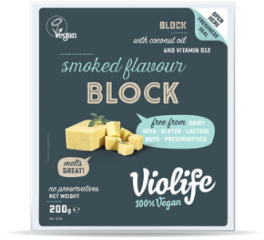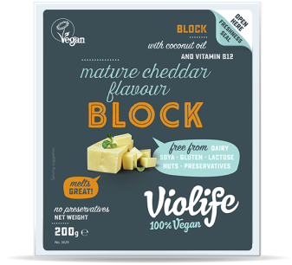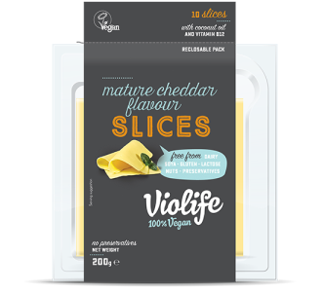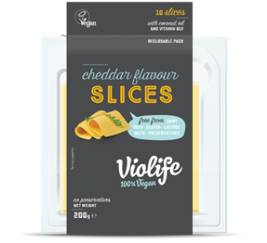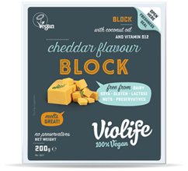

**Smoked Flavour (block/slices)**

**Cheddar (block/slices)**

**With Herbs (block/slices)**

**Original (block/slices)**

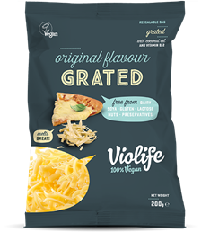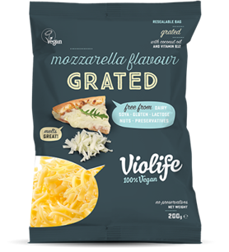

**Grated Original Flavour**

**Grated Mozzarella Flavour**

**Mozzarella Flavour (block/slices)**

**Mature Cheddar (block/slices)**

**Low Protein Cheese**

**Violife Cheese**

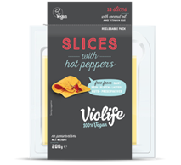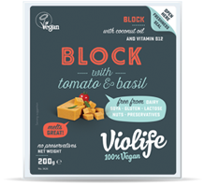The following cheeses contain exchanges when consumed in certain amounts.

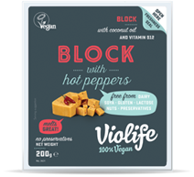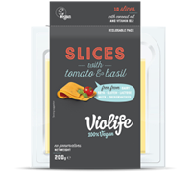

**Hot Peppers (block/slices)**

* Up to 9 slices = free
* 10 slices = ½ exchange
* Up to 200g block = free
* Full block (200g) = ½ exchange

**Tomato & Basil (block/slices)**

* Up to 3 slices = free
* 4 slices = ½ exchange
* Up to 60g block = free
* 70g block = ½ exchange

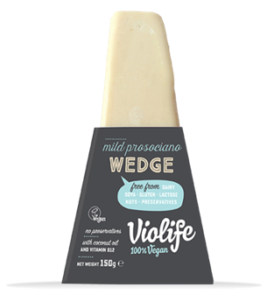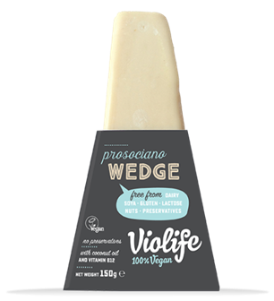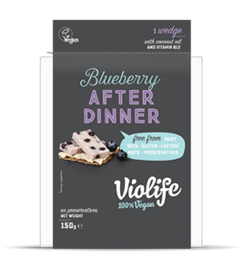

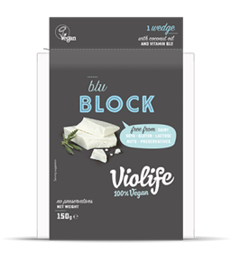

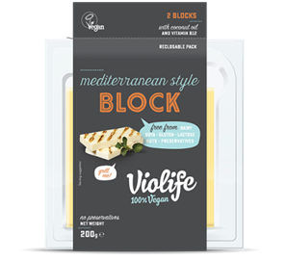

**Cranberry After Dinner Wedge**

* *50g = free*
* *60g = ½ exchange*
* *130g = 1 exchange*

**Mediterranean Style Block**

* *20g = free*
* *30g= ½ exchange*
* *70g= 1 exchange*

**Blu Block**

* *15g= free*
* *20g= ½ exchange*
* *40g=1 exchange*

**Blueberry After Dinner Wedge**

* *50g = free*
* *60g = ½ exchange*

***Prosociano Wedge***

* *20g = free*
* *30g = ½ exchange*
* *50g = 1 exchange*

**Mild Prosociano Wedge**

* *20g = free*
* *30g = ½ exchange*
* *70g = 1 exchange*

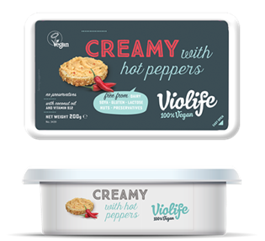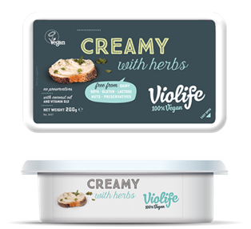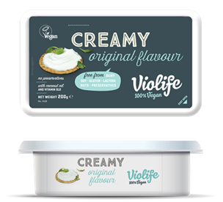

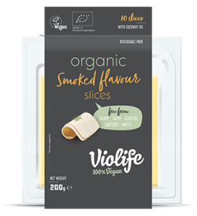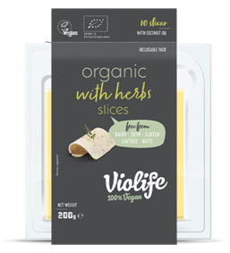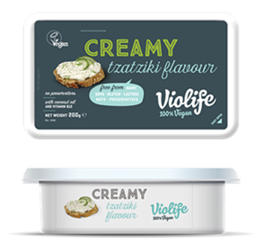

**Organic Original (block/slices)**

* *1 slice = free*
* *2-3 slices = ½ exchange*
* *4 slices = 1 exchange*
* *20g block = free*
* *30g=½ exchange*

**Creamy Tzatziki Flavour**

* *30g = free*
* *50g = ½ exchange*
* *110g = 1 exchange*

**Creamy with Hot Peppers**

* *30g = free*
* *50g = ½ exchange*

**Creamy with Herbs**

* *30g = free*
* *50g = ½ exchange*

**Creamy Original**

* *30g = free*
* *80g = ½ exchange*
* *160g = 1 exchange*

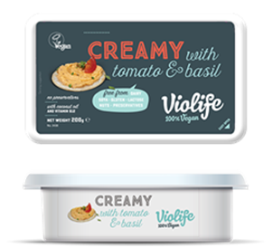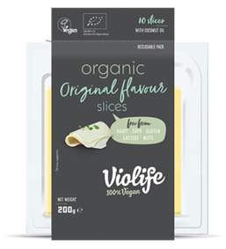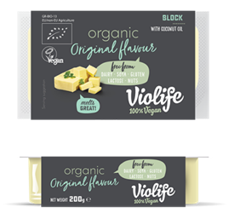

**Creamy Tomato & Basil**

* *30g = free*
* *40g = ½ exchange*
* *90g = 1 exchange*

**Organic Smoked Flavour**

* *1 slice = free*
* *2-3 slices = ½ exchange*
* *4 slices = 1 exchange*

**Organic with Herbs**

* *1 slice = free*
* *2-3 slices = ½ exchange*
* *4 slices = 1 exchange*

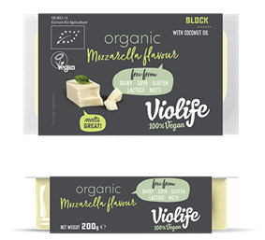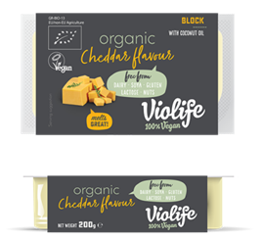

**Organic Mozzarella Flavour**

* *20g = free*
* *30g = ½ exchange*
* *70g = 1 exchange*

**Organic Cheddar Flavour**

* *20g = free*
* *30g = ½ exchange*
* *70g = 1 exchange*

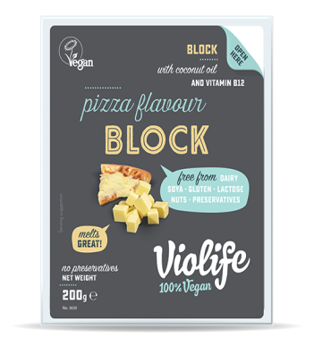

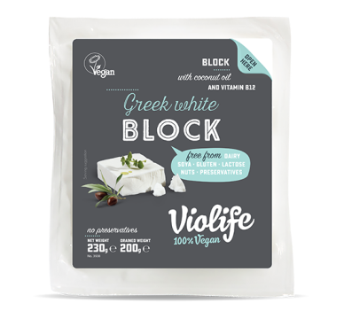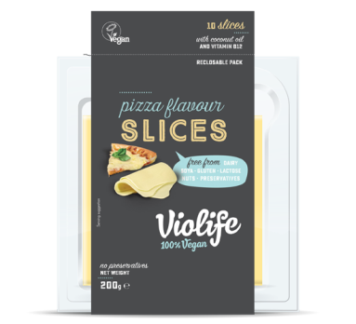

**Pizza Flavour (block/slices)**

* *1 slice = free*
* *30g = free*
* *Up to 100g = free*

**Greek White Block**

* *30g = free*
* *Up to 100g = free*

Violife Cheese is available from Dunnes Stores, Tesco and many health food stores.

It is also available to buy online from the following:

www.nourish.ie (standard delivery charge of €4.99, free shipping over €30)

www.plantgoodness24.ie (nationwide delivery ~€7.50, free delivery on orders over €65)

www.alternativestores.com (shipping cost ~ free delivery over £75.00 or £12.99 on orders under)

**VegAmigo Grated Melty Pizza Cheese 1kg** (Protein Free)

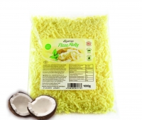

VegAmigo Cheese available to buy online from:

www.alternativestores.com (shipping cost ~ £12.99)

**Nature & Moi Cheese**

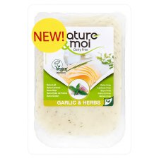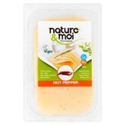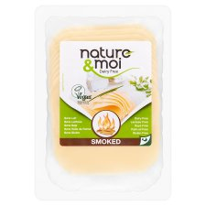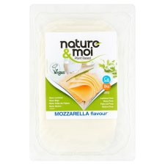

**Nature & Moi Slices Smoked Flavour/Mozzarella Flavour/Garlic and Herb/Hot Peppered Flavoured**

* *1 slice (20g) = free*
* *2 slices (40g)= ½ exchange*

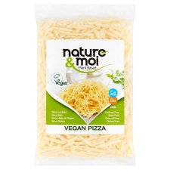

**Nature & Moi Grated Pizza Flavour**

* *Up to 60g = free*
* *80g = ½ exchange*

Nature & Moi Cheeses are available in Tesco

**Koko Dairy Free Cheese**

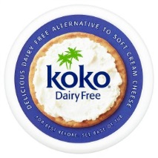

**Koko Dairy Free Soft Cream Cheese Alternative**

* *1 portion (30g) = free*
* *Up to 75g = free*
* *100g = ½ exchange (0.4g protein)*

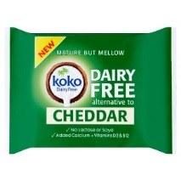

**Koko Dairy Free Cheddar Cheese Alternative**

* *1 portion (30g) = free*
* *Up to 40g = free*
* *100g = ½ exchange (0.7g protein)*

Koko Dairy Free Cheeses are available in Dunnes Stores.

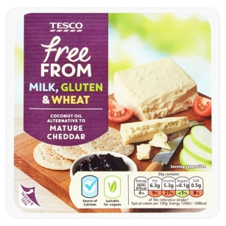**Tesco Free From Cheese**

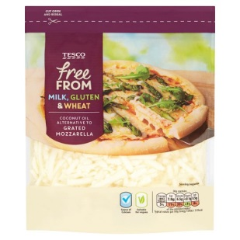

**Grated Mozzarella Alternative**  **Mature Cheddar Alternative**

* *30g = free (0.2g protein)*
* *Up to 50g = free*
* *100g = ½ exchange (0.6g protein)*
* *30g = free (<0.1g protein)*
* *Up to 100g = free*
* *400g = ½ exchange(0.4g protein)*

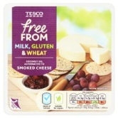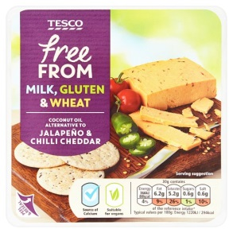

**Jalapeno And Chilli Cheese Alternative Smoked Cheese Alternative**

* *30g = free (0.2g protein)*
* *Up to 60g = free*
* *100g = ½ exchange (0.5g protein)*
* *30g = free (0.2g protein)*
* *Up to 60g = free*
* *100g = ½ exchange (0.5g protein)*

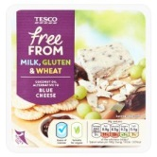

**Blue Cheese Alternative**

* *30g = free (0.1g protein)*
* *Up to 75g = free*
* *100g = ½ exchange (0.4g protein)*

**This information is current at the time of printing; please check individual labels to ensure the protein content has not changed.**

Date of print: February 2019

For review: February 2021