

**Koko Dairy Free Yoghurt Alternative**

Now available at Dunnes Stores and health food shops

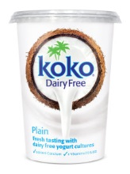

Koko Dairy Free Original Plain (500g pot)

125g = 1 exchange (0.8g protein)

Koko Dairy Free Strawberry, Raspberry, Peach & Passionfruit, Coconut & Lemon

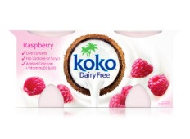125g pot = 1 exchange (0.8g protein)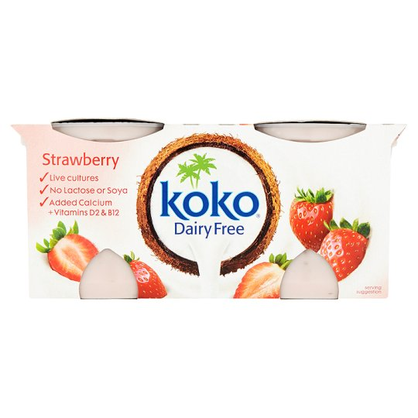

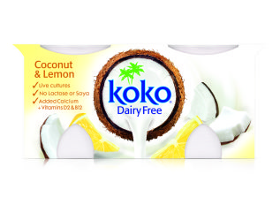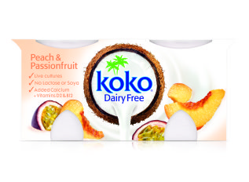

This information is correct at time of printing. Please check individual labels to ensure the protein content has not changed.

*National Centre for Inherited Metabolic Disorders*

Updated March 2019