Hooba Foods
https://hoobafoods.com/
Product Name | Number of Exchanges | Amount of Protein
Breakfast Style Sausage  (1 sausage=50g) | 1 sausage = 1 exchange  2 sausages = 2 ½ exchanges | 1 sausage = 1.15g protein  2 sausages= 2.3g protein
Cumberland Style Sausage  (1 sausage=50g) | 1 sausage = 1 exchange  2 sausages =2 ½ exchanges | 1 sausage = 1.15g protein  2 sausages= 2.3g protein
Apple and Sage Flavour Sausage  (1 sausage=50g) | 1 sausage = 1 ½ exchanges  2 sausages = 3 exchanges | 1 sausage = 1.5g protein  2 sausages = 3g protein
Chorizo Flavour Sausage  (1 sausage=50g) | 1 sausage = 1 ½ exchanges  2 sausages = 3 exchanges | 1 sausage = 1.4g protein  2 sausages = 2.8g protein
Harissa Style Sausage  (1 sausage=50g) | 1 sausage = 1 ½ exchanges  2 sausages = 3 ½ exchanges | 1 sausage = 1.7g protein  2 sausages = 3.4g protein
Hooba Meat-Free Burger | 1 burger (125g)= 2 ½ exchanges | 1 burger = 2.6g protein
Hooba Meat-Free Mince | 100g = 2 exchanges | 100g = 2g protein

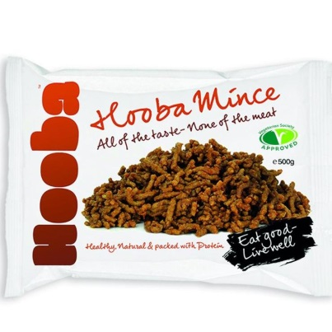
Information obtained from supplier and is correct at time of print. Please always check labels.

