Xotic Deluxe Dessert (Low Protein Dessert)

Available from most health food shops at a cost of approx. €1.15 per pot
Xotic hint of lime deluxe dessert

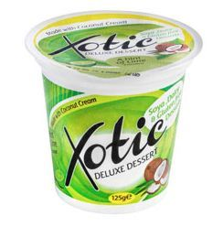 = 1 exchange (0.75g protein) per pot
Xotic hint of lemon deluxe dessert
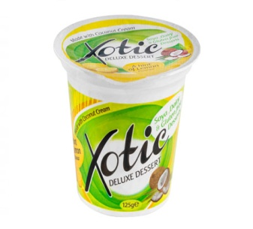= 1 exchange (0.75g protein) per pot

Xotic Dessert Mango & passionfruit
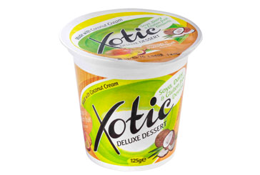= 1 exchange (0.75g protein) per pot
Xotic Summer fruits
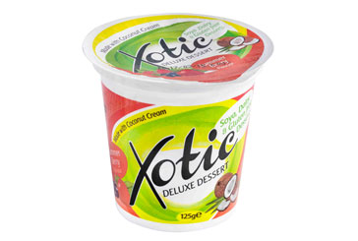= 1/2 exchange (0.63g protein) per pot

