Fate Mango & Strawberry Cobbler
Ingredients
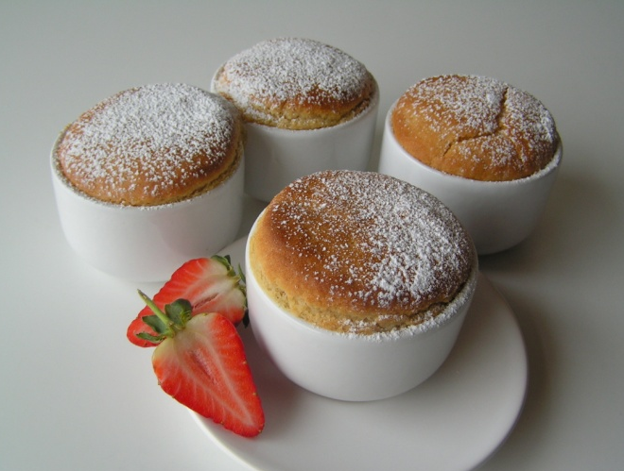
Fruit Base
1 medium fresh mango
8-10 medium sized fresh strawberries
4 tablespoons pure orange juice
Cobbler Topping
200g Fate Low Protein All-Purpose Mix
50g block margarine
Pinch salt
1 teaspoon baking powder
60g light soft brown sugar
120ml pure orange juice
Preheat oven to Gas Mark 5/190°C/375°F
Method
Fruit Base
- Peel the mango and cut into small pieces.
- Cut the strawberries into quarters and place into ovenproof ramekin dishes in equal proportions.
- You should fill the dishes about two thirds full.
- Add 1 tablespoon pure orange juice to each dish.
Cobbler Topping
- In a mixing bowl, place the Fate Low Protein All-Purpose Mix. Add the salt. Rub in the margarine until the mixture resembles breadcrumbs. Add the baking powder and sugar. Stir well.
- Measure the pure orange juice and add it to the bowl. Stir well using a large metal spoon until the mixture is smooth and creamy. Leave to stand for 2-3 minutes.
- Place the cobbler topping into the dishes on top of the fruit.
- Bake in a preheated oven for about 25 minutes until the topping is cooked and golden brown. If you are unsure, use a skewer and push it into the centre of the topping. It should come out clean.
- Serve hot or cold.
- The puddings can be frozen.

This recipe has been provided by ©Fate Special Foods

