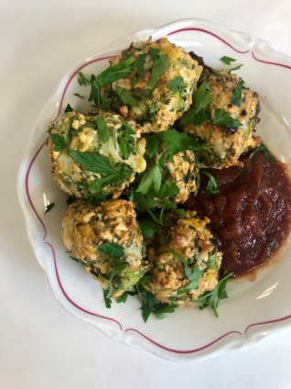
Banging Broccoli Balls
Ingredients
1 150g packet Loprofin crackers
300g (about 1 head) broccoli
2 medium sized eggs (60g/egg)
1 tablespoon Loprofin whole egg replacer powder
200g Violife Mozzarella grated cheese
¼ a brown onion, diced
2 tablespoons chopped fresh parsley
Salt and pepper
Equipment
Food processor, kettle, large bowl and a lined oven tray
Time
Preparation: 25 mins
Cooking: 20 mins
Serving size
Recipe makes 13 broccoli balls (1 portion = 1 ball)
Nutrition information
1 ball = 1 exchange (from egg, 1 small egg = 6.5 exchanges)
Allergens: egg
Calories per portion: 125kcal
Method
- Pre-heat oven to 200°C fanbake
- Bring a jug of water to the boil
- Blend packet of Loprofin crackers in food processer until they resemble the consistency of coarse bread crumbs
- Cut broccoli heads into florets and place in a large bowl. Once water has boiled cover the broccoli for 1 minute then drain well
- Blitz the broccoli in a food processor for a few quick pulses until broccoli is chopped finely but not pureed
- Place broccoli in a large bowl with the crushed Loprofin crackers, eggs, cheese and onion. Salt and pepper can be added for taste for older children and adults, do not add for younger children (under 5 years)
- Mix 1 tablespoon of Loprofin whole egg replacer with 3 tablespoons of water until smooth. Add to the bowl with other ingredients
- Mix all ingredients until combined. Roll into 13 evenly sized balls and place onto a lined oven tray
- Cook for 20 minutes or until browned, flip once after around 10 minutes of cooking
Switches
To adapt the recipe to contain the following exchanges per portion | Add or replace
1.5 | Replace Loprofin egg replacer with 1 small egg (60g), i.e. total of 3 eggs in the mixture
2 | Replace 60g of Violife cheese with 60g of standard grated Mozzarella cheese
3 | Replace 120g of Violife cheese with 120g of standard grated Mozzarella cheese

Chef’s top tips
- Serve with tomato relish as a snack or as part of a main meal
- The mixture can be crumbly when forming the balls. Wetting your hands regularly helps this. Extra egg replacer mixed with water as in the recipe above can be added to help bind the mix if needed, without adding extra protein
- Choose a Violife cheese e.g. grated Mozzarella designed for pizzas means the cheese will melt in the oven which helps the balls stick together. Block Violife cheeses do not melt as well
- To help make even sized balls you can weigh the final mixture on a kitchen scale and divide this by 13 to get the weight of a single ball. All remaining balls can be prepared to this size without needing to be weighed.
Freezing
Balls can be frozen once cooled but do lose the crispy outside texture when defrosted. They can be re-heated in a non-stick fry pan to become crispy again.

