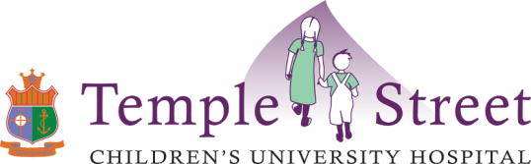
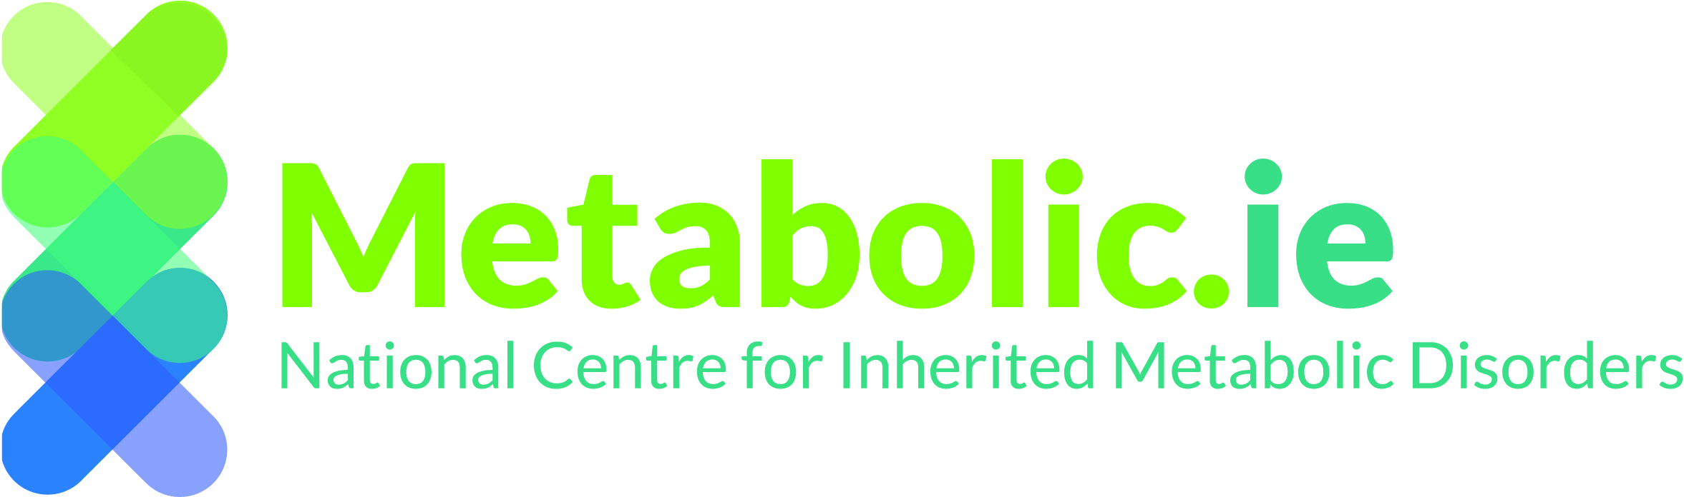

GUIDELINES FOR THE CLINICAL MANAGEMENT OF A POSITIVE NEWBORN SCREEN FOR
MEDIUM CHAIN ACYL –CoA DEHYDROGENASE DEFICIENCY (MCADD)

Medium Chain Acyl CoA Dehydrogenase Deficiency (MCADD) is a rare genetic metabolic disorder due to an enzyme deficiency in which the body cannot convert certain fats (medium chain) into energy. This can cause the body to run out of energy particularly when feeding poorly or sick - leading to serious illness such as hypoglycaemia, liver dysfunction, high ammonia levels, seizures, encephalopathy, coma and death. Once diagnosed, MCADD can be managed effectively by regular feeds and carbohydrate intake and avoidance of fasting. In the neonatal period drowsiness or poor feeding can be serious signs of encephalopathy. Normal blood glucose levels do not exclude MCADD.

ACTION ON A POSITIVE NEWBORN SCREENING RESULT FOR MCADD:
SAME DAY Medical review at local paediatric/neonatal unit -
- Examine the baby and measure weight
- Detailed feeding history
- Check blood glucose, U&Es, LFTs
- Take the following samples and send to the metabolic lab, Temple Street Children’s University Hospital:
  - Acyl-Carnitine profile (dried blood spot card)
  - Urine for organic acids

IF BABY IS UNWELL (OR BECOMES UNWELL PRIOR TO CONFIRMATION OF DIAGNOSIS):
Discuss immediately with Metabolic Team and Neonatal team
- Start IV Dextrose 10% & electrolytes at 150mls/kg/day.
- Take investigations as outlined above + venous blood gas + ammonia + CK along with other investigations and treatment as clinically indicated.

IF BABY IS WELL:
- Ensure baby is feeding sufficiently i.e. :
  - Breast feeding every 2-3 hours by day, every 3 hours by night (at least 10 minutes on the breast). After every feed offer a top up feed of min. 20mls of Expressed Breast Milk (EBM) or infant formula or 10% carbohydrate solution.
or
  - Bottle feeding well with EBM or infant formula every 3 hours
- Discuss with and refer to metabolic team for follow up upon confirmation of diagnosis of MCADD

CONTACT NUMBERS:
Newborn Screening Lab: 00 353 1 8784277
Temple Street Children’s University Hospital: 00 353 1 8784200

OTHER RESOURCES:
National Newborn Bloodspot Screening Programme on www.hse.ie
National Centre for Inherited Metabolic Disorders www.metabolic.ie
Version 1 28/11/2018

