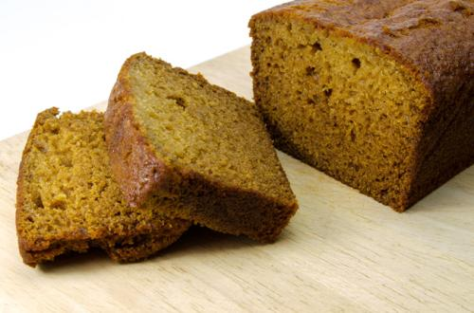
Gingerbread Microwave Recipe
Ingredients
75g/3oz margarine
150g/6oz black treacle
50g/2oz soft dark brown sugar
150ml/6fl.oz water
½ teaspoon bicarbonate soda
150g/6oz low protein flour mix
½ teaspoon gluten free baking powder
1 teaspoon ground ginger
1 teaspoon of mixed spice
Method
- Place the margarine, treacle, sugar and water into a bowl and heat on high for 3 minutes.
- Sieve together the flour mix, baking powder, bicarbonate of soda and mixed spice and add the melted mixture to the dry ingredients. Mix until smooth.
- Grease a rectangular container (7’’ x 4.5’’ x 2’’) and line the base.
- Pour in the mixture and cook at roast for 8 minutes or until the cake comes away from the sides of the dish.
- Cool on a wire rack.

